ENTEBBE BRIGHT SECONDARY SCHOOL
S.2 BIOLOGY ASSESMENT 1 2022 TERM 3
TIME: 1HR 30 MINS
ANSWER ALL QUESTIONS
QUESTION ONE.
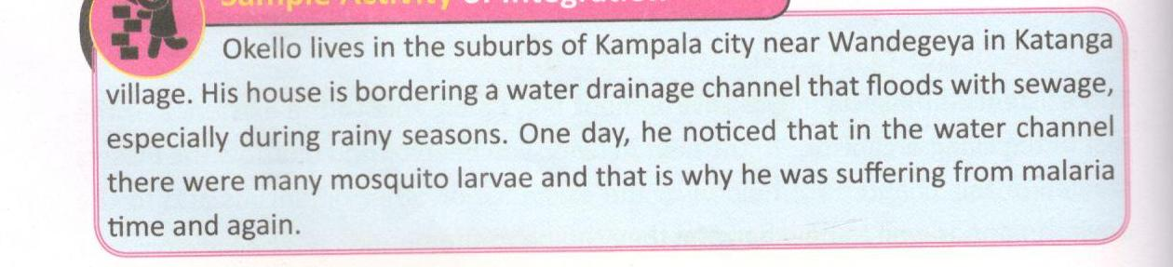

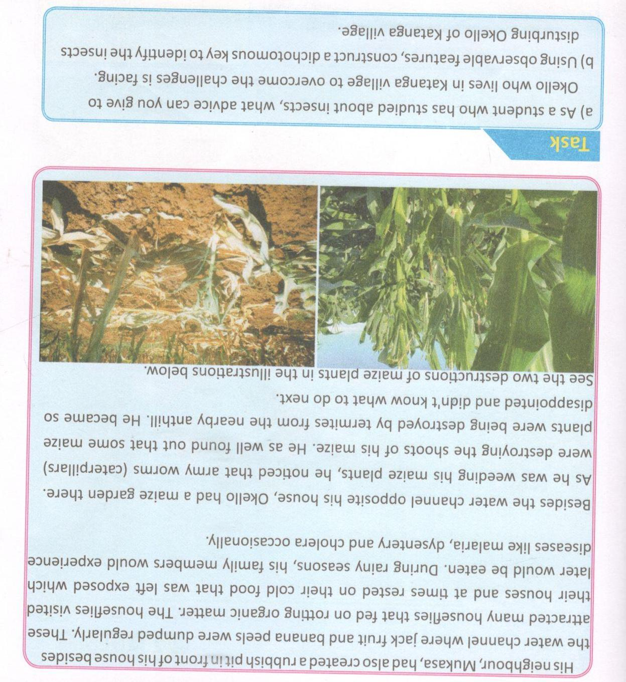

QUESTION 2

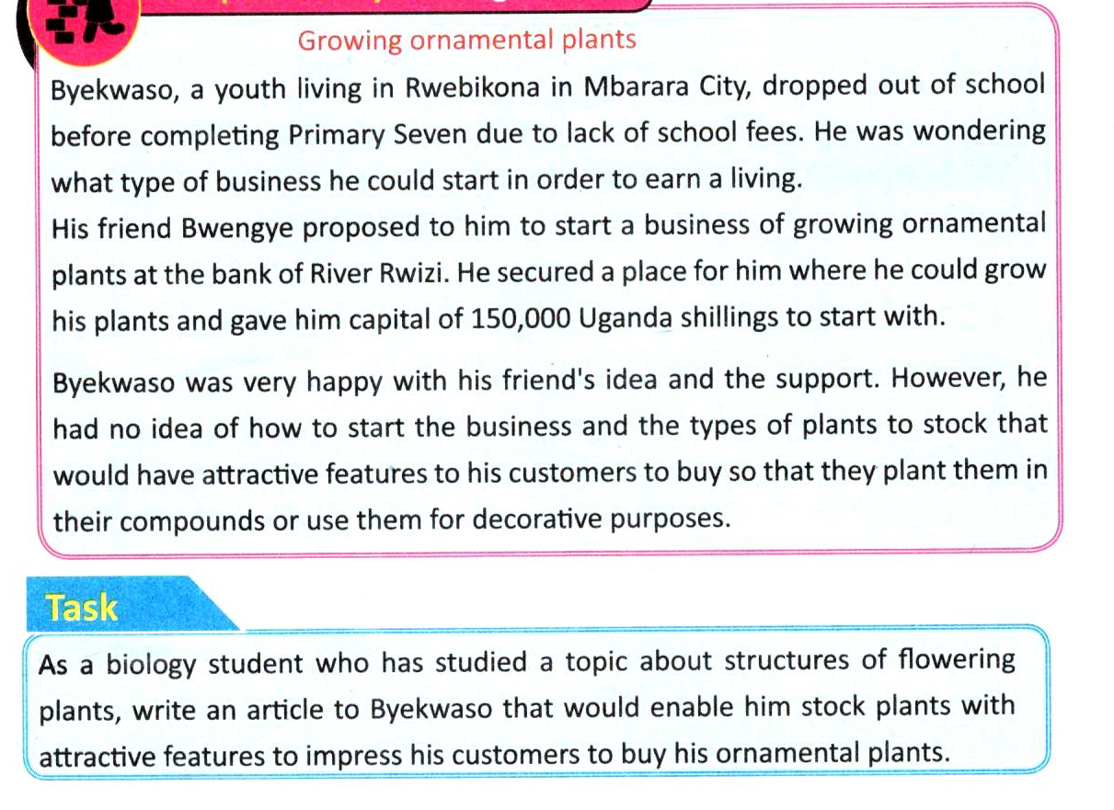
Question 3
. Describe how you would carry out an experiment to determine the percentage of air in the soil.
b). give an advise to the farmer who faces a challenge of soil erosion while cultivating on a slope of a mountain.

END

